Temporal Trends & Incident Response Analytics Dashboard
Milestone 3 Report | Power BI Security Incident Analytics
1. Objective
The objective of Milestone 3 was to extend the Threat Classification & Geospatial Intelligence work from Milestone 2 with two further analytical lenses: time and response operations. The Temporal Incident Analytics dashboard answers when incidents happen — by day of week, month, and season — so that staffing and monitoring can be planned around predictable peaks rather than spread evenly across the year. The Incident Response Analytics dashboard answers how well the organization responds once an incident is logged, tracking response time by team, resolution time by severity, workload distribution, and response status across states. Together, the two dashboards move the project from describing what incidents occurred (Milestone 1) and where they are most severe (Milestone 2) to when they occur and how efficiently they are being handled.
Key Performance Indicators at a Glance
TOTAL INCIDENTS  2K | PEAK INCIDENT DAY  Saturday | PEAK INCIDENT MONTH  June | MOST FREQUENT THREAT  Phishing
TOTAL RESPONSES  2K | RESPONSE EFFICIENCY %  45.13 | AVG. RESPONSE TIME  1.09 | AVG. RESOLUTION TIME  13.38

2. Dashboard Screenshots
2a. Temporal Incident Analytics
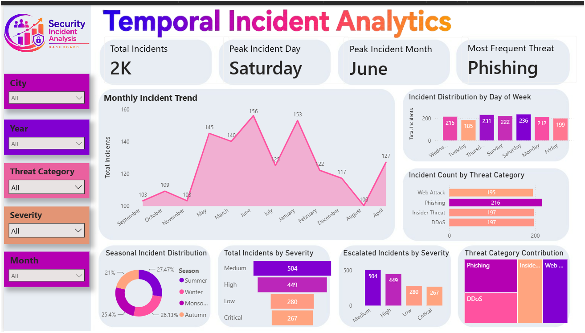
Figure 1: Temporal Incident Analytics Dashboard — Power BI
This dashboard filters incidents by City, Year, Threat Category, Severity, and Month, and centers on a Monthly Incident Trend area chart alongside an Incident Distribution by Day of Week bar chart and an Incident Count by Threat Category ranking. The lower band adds a Seasonal Incident Distribution donut, a Total Incidents by Severity funnel, an Escalated Incidents by Severity comparison, and a Threat Category Contribution treemap.

2b. Incident Response Analytics
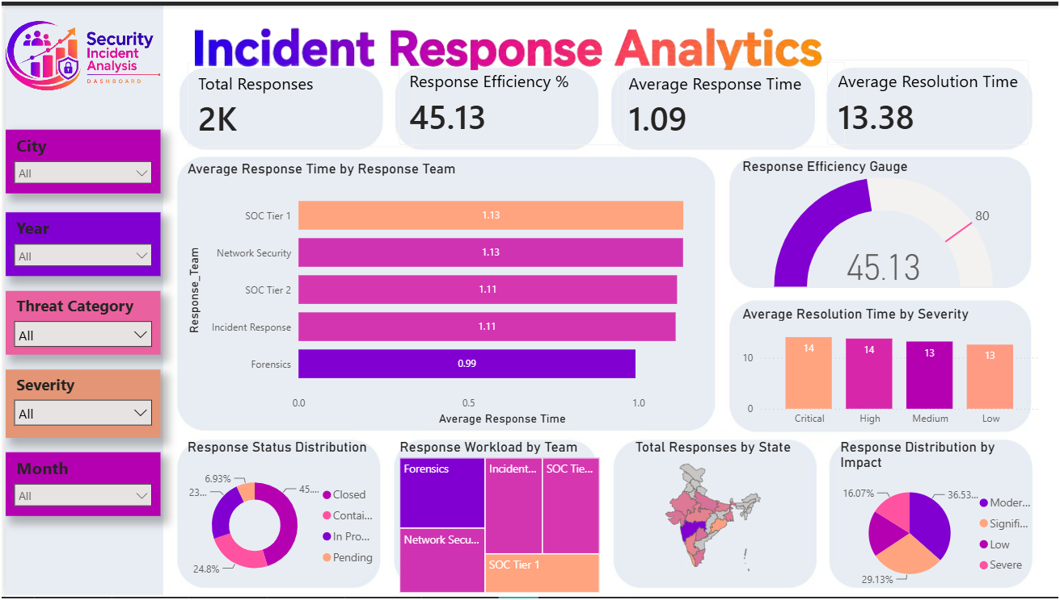
Figure 2: Incident Response Analytics Dashboard — Power BI
Using the same City, Year, Threat Category, Severity, and Month filters, this dashboard tracks Average Response Time by Response Team, a Response Efficiency Gauge, and Average Resolution Time by Severity. The lower band shows a Response Status Distribution donut (Closed, Contained, In Progress, Pending), a Response Workload by Team treemap, a Total Responses by State map of India, and a Response Distribution by Impact pie chart.
3. Three Key Insights
- Insight 1 — Incident volume follows a predictable temporal rhythm rather than occurring randomly. The Monthly Incident Trend shows a clear mid-year climb, rising from 103–109 incidents in September–November to a peak of 156 in June, before falling sharply to 100 in August and rebounding to 127 in April. Combined with Saturday being the single Peak Incident Day and June the Peak Incident Month, this indicates the organization can anticipate — rather than merely react to — its busiest periods.
- Insight 2 — There is a wide gap between how fast the team responds and how fast incidents are actually resolved. Average Response Time sits at a fast 1.09 hours across teams, with Forensics fastest at 0.99 and SOC Tier 1 and Network Security slowest at 1.13. Yet Average Resolution Time is 13.38 hours and Response Efficiency is only 45.13%, showing that the delay is not in first contact but in the work required to fully close an incident after it has been picked up — most visibly for Critical and High severity cases, which take the longest to resolve at 14 hours each.
- Insight 3 — The threat mix and escalation pattern seen in earlier milestones persists at the operational level. Incident Count by Threat Category again shows Phishing (216), Insider Threat (197), DDoS (197), and Web Attack (195) clustered tightly together, confirming the diversified exposure identified in Milestone 1. Escalated Incidents by Severity mirrors this concentration risk, with Medium (504) and High (449) severity incidents accounting for the large majority of escalations versus Low (280) and Critical (267), reinforcing that the middle severity tiers — not just the critical ones — are driving overall response workload.
4. Two Business Recommendations
1. Build proactive staffing schedules around the identified peak periods. Since incidents predictably cluster on Saturdays, in June, and through the broader mid-year window, response teams should shift from flat year-round staffing to a surge model that adds capacity ahead of these known peaks and scales back during the low-volume August trough — reducing the risk of backlog building during the busiest weeks.
2. Standardize post-response resolution workflows using the Forensics team's practices as a benchmark. With response time already fast but resolution time nearly 12 times longer, the biggest efficiency gain lies after initial response, not before it. Codifying Forensics' 0.99-hour approach into shared runbooks for SOC Tier 1 and Network Security, with priority focus on Medium and High severity cases, would directly raise the 45.13% efficiency score and shorten the 13.38-hour resolution time.

